**Project Report**

**Submitted by:-**

Param Tank (195163693002)

Vishal Joshi (185160693011)

Bhargav khamal (185160693012)

**Under Supervision of:-**

Prof. Pradeep Patel



**L. D. College of Engineering**

**Ahmedabad - 380015**

**Internal Guide:** **External Faculty:**

Prof. Pradeep Patel (Examiner)

Sign: ______________ Sign: ______________





**L. D. COLLEGE OF ENGINEERING**

**Ahmedabad-380 015**

**CERTIFICATE**

This is to certify that the project entitled **Software Project – 3(SP-III)** has been carried out by **Sumeet Tilokani(175160693027),** **Prajapati Sonu (175160693022)**, and **Nisarg Sheth(175160693016)** under my guidance in fulfilment of the degree of **Master of Computer Application(MCA)** in **SEMESTER-**V of **Gujarat Technological University,** **Ahmedabad** during the academic year **2019**.

**Prof. Pradeep Patel**  **Shital**

(Internal Guide) (Head of the Department)

**Acknowledgment**

We are using this opportunity to express our gratitude to everyone who supported us through the course of this MCA project.

We are thankful for their aspiring guidance, invaluably constructive criticism and friendly advice during the project work.

We are sincerely grateful to them for sharing their truthful and illuminating views on a number of issues related to the project.

Last but not the least, a very special acknowledgment and warm regards to the mentor of this subject **Prof. Pradeep Patel** for her invaluable guidance during the course of this project work and helping us at each level of our project.

**Abstract**

The aim of this project is to develop a system that can offer movie advice to people looking for movies they like or looking for similar ones they love. In this document, we will present to you what is our project will be look like, what are the algorithms that we may use and which softwares, systems uses these algorithms.

**Index**

|  |  |  |
| --- | --- | --- |
| Sr. No | Topic | Page Number |
|  | Introduction  1.1 Existing System  1.2 Need for the New System  1.3 Objective for the New System  1.4 Problem Definition  1.5 Core Components  1.6 Project Profile  1.7 Assumptions and Constraints  1.8 Advantages & Disadvantages of the Proposed System |  |
|  | Requirement Determination & Analysis   * 1. Requirement Determination   2. Targeted Users |  |
|  | System Design   * 1. Use Case Diagram   2. Class Diagram   3. Interaction Diagram   4. Activity Diagram   5. Data Dictionary |  |
|  | Development  4.1 Coding Standards |  |
|  | Agile Documentation   * 1. Agile Project Charter   2. Agile Roadmap/Schedule   3. Agile Project Plan   4. Agile User Story   5. Agile Release Plan   6. Agile Sprint Backlog   7. Agile Test Plan   8. Earned-value and burn charts |  |
|  | Proposed Enhancements |  |
|  | Conclusion |  |
|  | Bibliography |  |

1. **Introduction**

Over the past 5 years, watching movies and series on digital platforms is now a part of our lives. While the film industry is slowly losing its influence, watching movies on the Internet and paying less for it is becoming a better and easier method for everyone. With the increase in our internet speeds, we are now able to watch movies or series from various platforms very comfortably. Some companies that foreseen this development have increased their investments in this field and have become the pioneers of this sector. As we can see from the Figure 1, the internet movie watching sector has increased over the years and will continue to increase at the same speed.

* 1. **Existing System**
* The assistance provided to the users is highly limited to the types of services that is being provided.
* Assistance through helpline is highly prone to unavailability that makes wthe users experience worse.
* The available services to the users are not accessible to the users in terms of locality.
* In India, majority of the users are completely unaware of the services that are available near to them.
* At times, they are made to stay in a position where the get no assistance due to unavailability.

**1.2 Need for the New System**

* The assistance provided to the users are in wide range where they can enjoy in all in one manner.
* The access to and the presence of services will be made to known to the users with Google Maps Navigation System.
* The user is provided with more services and support to ensure that they have a good travelling experience.
* The user can have easy access to the services based on the current location using Google Maps Navigation System.
* The services are provided in a wide range so that travellers enjoy the maximum benefit out of it.

**1.3 Objective for the New System**

* The services provided are made available with the information of the service providers with which the user can have access.
* The proposed system connects Service Providers and the customers through this system.
  1. **Problem Definition**
* During festive seasons, car breakdown cases increase more as the long journeys put vehicles more at risk of breaking down.
* In the case of breakdown on State Route and Route in Town, it can be difficult to get help because if the driver is not familiar with that place.
* When it comes to breakdown in rural areas, it could be worse as the point of breakdown is far away from Car Repair Service Providers.
* Another problem is the rise of tow truck scam where a tow truck appears at the scene out of nowhere, offering tow service. After towing away the vehicle, the scammer will demand a large amount of money from the victim to get back the car.
* There have been many cases where the tow truck operators themselves engineered the accidents, through the use of oil or nails on a targeted stretch of road.
* All these happen on the road as the drivers will get panicked when cars break down and they have no idea who to seek for help. The scammers take advantage of this and make their service looks convenient, but it is actually a scam.
* From the above problems, it is important that further investigations should be made to solve this problem faced by the public.
* There must be a solution to this problem, not just to decrease the tow truck scam incidents, but to help the public to contact a trustworthy service operator to assist them in such situations too.

**1.5 Core Components**

There are several core components that has been used for developing the web application of NS Motor Club that includes:

Front End: - Python-Django Framework

Back End: - MySQL

Software Used: - Visual Studio Code, XAMPP

 

 

  

* 1. **Project Profile**

**1.7 Assumptions & Constraints**

**Assumptions:**

* + As part of their efforts to ensure prompt and reliable service for users, NS Motor Club assumes that it will optimize their vehicles travel patterns.
  + The main focus is to provide the seamless and user-friendly experience of the new system that they won’t find any difficulty in accessing any products or services.
  + We also assume that every end-user will provide accurate details so that we could provide the best quality service by assigning the right person at the right time with least possible cost.

**Constraints:**

* Data Security.
* User Verification.
* The system requires an active Internet connection.
* Google Maps Navigation System (Current location).
* Payment Gateway Process.

**1.8 Advantages & Limitations of Proposed System**

**Advantages:-**

* The end-user is provided with more services and support to ensure that they have a good travelling experience.
* It helps to find the service providers easily and quickly as it becomes difficult to find them in the nearby area especially when you are travelling to a new place.
* The system can have easy access to the services based on the current location by providing the address at the time of making appointment request.
* The membership charges are very nominal as compared to other roadside assistance providers in India.
* There are wide range of products relating to spare-parts available for the end-user to purchase online as the application keeps a “record” of all orders that have been placed, which you can check at any moment.

**Limitations:-**

* System will provide inaccurate results if data is not entered properly.
* At times the users are made to stay in a position where they get no assistance due to unavailability.

**Requirement Determination and Analysis**

**2.1 Requirement Determination**

Requirement determination (IRD) is frequently and convincingly presented as the most critical phase of information system.

* **Interviewing:** It is the primary phase of collecting information. No project can be conducted without interviewing.
* **Questionnaires:** We have gathered information from many people in a very short time with the help of questionnaires. To conduct an effective survey, the users were grouped differently.
* **Observation:** People are not always very reliable informants, even when they try to be reliable and tell what they think is the truth. However, observation can cause people to change their normal operation behaviour.
* **Analysing procedures and other documents:** By examining existing system and organizational documentation, we can find details such as problem with existing systems, opportunities to meet new needs, etc.
* **Joint Application Design (JAD):** The main idea behind JAD is to bring together the key people involved with the system.

**Prototyping:** It is a means of exploring ideas before you invest in them.

|  |  |  |  |  |  |  |
| --- | --- | --- | --- | --- | --- | --- |
| Characteristic | Interviews | Questionnaires | Observation | Document analysis | JAD | Prototyping |
| Information Richness | High | Medium to low | High | Low (passive) and old | High | Medium to High |
| Time Required | Can be extensive | Low to moderate | Can be extensive | Low to moderate | Dedicated period of time of all kinds of involved people | Moderate and can be extensive |
| Expense | Can be high | Moderate | Can be high | Low to moderate | High | High |
| Chance for Follow-up and probing | Good | Limited | Good | Limited | Good | Good |
| Confidentiality | Interviewee is known to interviewer | Respondent can be unknown | Observee is known to interviewer | Depends on nature of document | All the people know each other | Usually know each other |
| Involvement of Subject | Interviewee is involved and committed | Respondent is passive, no clear commitment | Interviewees may or may not be involved and committed depending on whether they know if they are being observed | None, no clear commitment | All kinds of people are involved and committed | Users are involved and committed |
| Potential Audience | Limited numbers, but complete responses from those interviewed | Can be quite large, but lack of response from some can bias results | Limited numbers and limited time of each | Potentially biased by which documents were kept or because document not created for this purpose | Potentially biased by the subordinator intentionally don’t want to directly point out his superior’s errors. | Limited numbers; it is difficult to diffuse or adapt to other potential users |

**2.2 Targeted Users**

NS Motor Club has been developed with the aim of targeting two major kind of users which consists of:

1. Clients or Customers
2. Service Providers or Merchants
3. **Customer:**

Customer can send a request and can appoint a mechanic on respective date-time. Also, they are provided with varied categories of car spare products which they can buy online at the same place.

1. **Service Provider:**

A service provider can perform various tasks such as viewing request received from customers and reach the location to work accordingly. He/she can also send feedback to the administrator.

**System Design**

**3.1 Use Case Diagram**

1. **Admin**:-

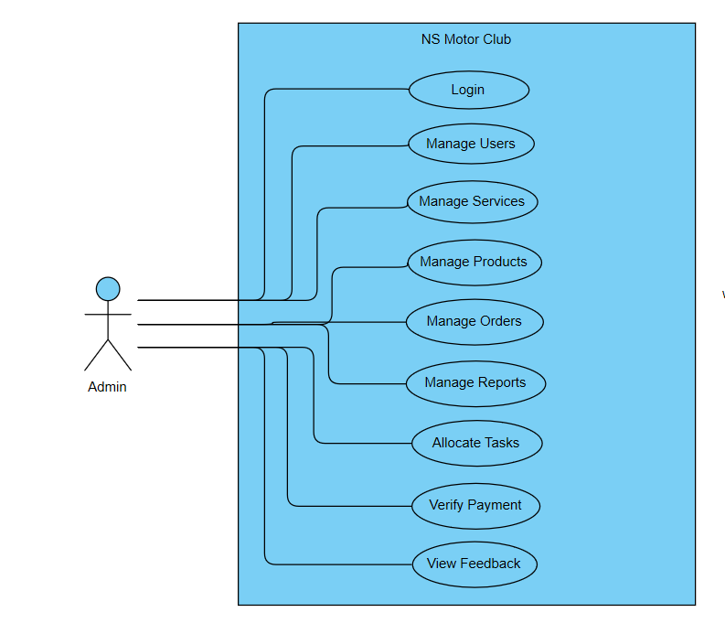

2. **User**:-

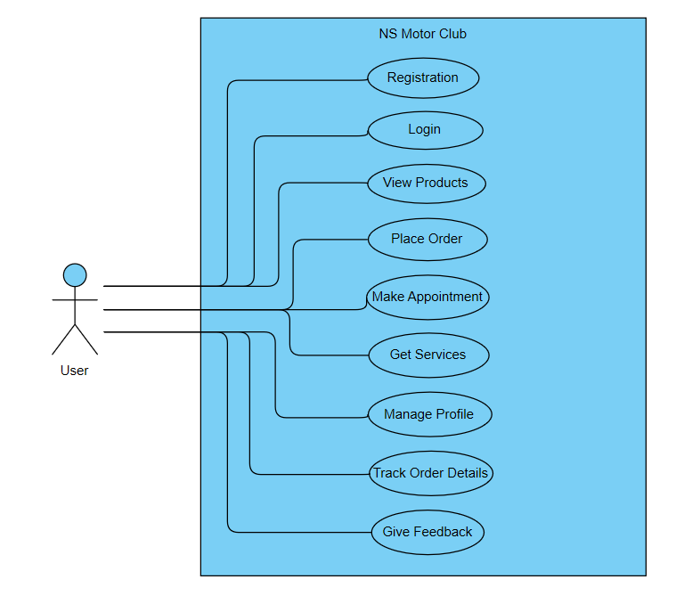

**3.2 Class Diagram**

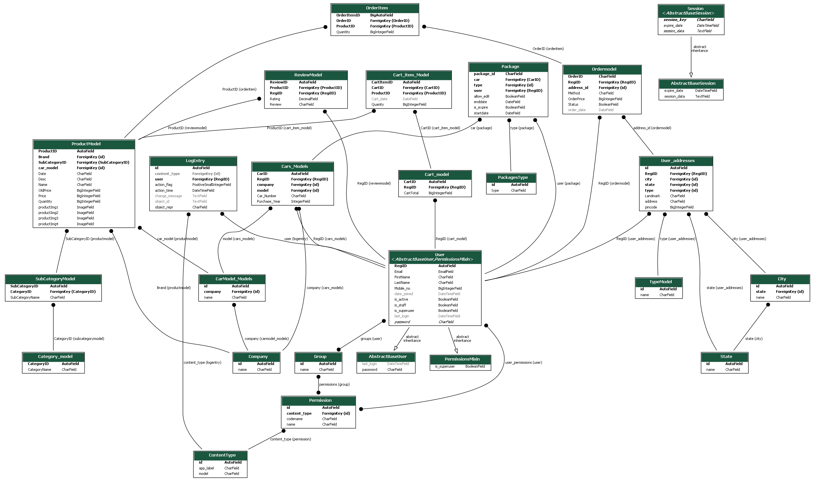

**3.5 Data Dictionary**

|  |  |
| --- | --- |
| **No.** | **List of tables** |
| 1 | Register |
| 2 | Company |
| 3 | Model |
| 4 | Car |
| 5 | Service |
| 6 | User-request |
| 7 | Merchant |
| 8 | Membership |
| 9 | Merchant-membership |
| 10 | Product |
| 11 | Product-Details |
| 12 | Cart |
| 13 | Checkout |
| 14 | Payment |

**Table Name:- User**

|  |  |  |  |  |
| --- | --- | --- | --- | --- |
| **Field-Name** | **Data-Type** | **Size** | **Constraint** | **Description** |
| Regi_ID | INT | 10 | Primary Key |  |
| FName | VARCHAR | 15 | Not Null |  |
| LName | VARCHAR | 15 | Not Null |  |
| Mob_No | BIGINT | 10 | Not Null |  |
| Email_Id | VARCHAR | 25 | Foreign Key |  |
| Is_Superuser | TINYINT |  | Not Null |  |
| Is_active | TINYINT |  | Not Null |  |
| Last_login | DATE/TIME |  | Not Null |  |
| Date_joined | DATE/TIME |  | Not Null |  |
| Is_staff | TINYINT |  | Not Null |  |
| Password | VARCHAR | 15 | Not Null |  |

**Table Name:- Company**

|  |  |  |  |  |
| --- | --- | --- | --- | --- |
| Field-Name | Data-Type | Size | Constraint | Description |
| Id | INT | 10 | Primary Key |  |
| Name | VARCHAR | 25 | Not Null |  |

**Table Name:- Car**

|  |  |  |  |  |
| --- | --- | --- | --- | --- |
| Field-Name | Data-Type | Size | Constraint | Description |
| CarID | INT | 10 | Primary Key |  |
| Purchase_Year | INTEGER | 10 | Not Null |  |
| Car_Number | VARCHAR | 25 | Not Null |  |
| Company_Id | INTEGER | 10 | Foreign Key |  |
| Model_Id | INTEGER | 10 | Foreign Key |  |
| Regi_ID | INTEGER | 10 | Foreign Key |  |

**Table Name:- Car_Model**

|  |  |  |  |  |
| --- | --- | --- | --- | --- |
| Field-Name | Data-Type | Size | Constraint | Description |
| Id | INT | 10 | Primary Key |  |
| Name | VARCHAR | 25 | Not Null |  |
| Company_Id | INTEGER | 10 | Foreign Key |  |

**Table Name:- Cart**

|  |  |  |  |  |
| --- | --- | --- | --- | --- |
| Field-Name | Data-Type | Size | Constraint | Description |
| CartID | INT | 10 | Primary Key |  |
| CartTotal | BIGINT | 20 | Not Null |  |
| Regi_ID | INTEGER | 10 | Foreign Key |  |

**Table Name:- Category**

|  |  |  |  |  |
| --- | --- | --- | --- | --- |
| Field-Name | Data-Type | Size | Constraint | Description |
| Id | INT | 10 | Primary Key |  |
| Name | VARCHAR | 25 | Not Null |  |

**Table Name:- Company**

|  |  |  |  |  |
| --- | --- | --- | --- | --- |
| Field-Name | Data-Type | Size | Constraint | Description |
| Id | INT | 10 | Primary Key |  |
| Name | VARCHAR | 25 | Not Null |  |

**Table Name:- State**

|  |  |  |  |  |
| --- | --- | --- | --- | --- |
| Field-Name | Data-Type | Size | Constraint | Description |
| Id | INT | 10 | Primary Key |  |
| Name | VARCHAR | 25 | Not Null |  |

**Table Name:- City**

|  |  |  |  |  |
| --- | --- | --- | --- | --- |
| Field-Name | Data-Type | Size | Constraint | Description |
| Id | INT | 10 | Primary Key |  |
| Name | VARCHAR | 25 | Not Null |  |
| State_Id | INTEGER | 10 | Foreign Key |  |

**Table Name:- Member_Type**

|  |  |  |  |  |
| --- | --- | --- | --- | --- |
| Field-Name | Data-Type | Size | Constraint | Description |
| Id | INT | 10 | Primary Key |  |
| Name | VARCHAR | 25 | Not Null |  |

**Table Name:- Merchant**

|  |  |  |  |  |
| --- | --- | --- | --- | --- |
| Field-Name | Data-Type | Size | Constraint | Description |
| MerchantID | INT | 10 | Primary Key |  |
| FirstName | VARCHAR | 25 | Not Null |  |
| LastName | VARCHAR | 25 | Not Null |  |
| Email | VARCHAR | 25 | Not Null |  |
| Location | VARCHAR | 25 | Not Null |  |

**Table Name:- Merchant_Membership**

|  |  |  |  |  |
| --- | --- | --- | --- | --- |
| Field-Name | Data-Type | Size | Constraint | Description |
| MembershipID | INT | 10 | Primary Key |  |
| StartDate | DATE/TIME |  | Not Null |  |
| EndDate | DATE/TIME |  | Not Null |  |
| Amount | INTEGER | 10 | Not Null |  |
| MemberTypeID | INTEGER | 10 | Foreign Key |  |
| Merchant_Id | INTEGER | 10 | Foreign Key |  |

**Table Name:- Merchant_Service**

|  |  |  |  |  |
| --- | --- | --- | --- | --- |
| Field-Name | Data-Type | Size | Constraint | Description |
| Merchant_Service_ID | INT | 10 | Primary Key |  |
| MerchantID | INTEGER | 10 | Foreign Key |  |
| Service_ID | INTEGER | 10 | Foreign Key |  |

**Table Name:- Order**

|  |  |  |  |  |
| --- | --- | --- | --- | --- |
| Field-Name | Data-Type | Size | Constraint | Description |
| OrderID | INT | 10 | Primary Key |  |
| OrderPrice | BIGINT | 20 | Not Null |  |
| Status | VARCHAR | 15 | Not Null |  |
| Method | VARCHAR | 25 | Not Null |  |
| Order_Date | DATE/TIME |  | Not Null |  |
| Regi_ID | INTEGER | 10 | Foreign Key |  |
| Address_Id | INTEGER | 10 | Foreign Key |  |

**Table Name:- Order_Item**

|  |  |  |  |  |
| --- | --- | --- | --- | --- |
| Field-Name | Data-Type | Size | Constraint | Description |
| OrderItemID | INT | 10 | Primary Key |  |
| Quantity | BIGINT | 10 | Not Null |  |
| Order_ID | BIGINT | 10 | Foreign Key |  |
| Product_Id | INTEGER | 10 | Foreign Key |  |

**Table Name:- Package**

|  |  |  |  |  |
| --- | --- | --- | --- | --- |
| Field-Name | Data-Type | Size | Constraint | Description |
| Package_Id | INT | 10 | Primary Key |  |
| Start_Date | DATE/TIME |  | Not Null |  |
| End_Date | DATE/TIME |  | Not Null |  |
| Is_expire | TINYINT |  | Not Null |  |
| Car_Id | INTEGER | 10 | Foreign Key |  |
| Type_Id | INTEGER | 10 | Foreign Key |  |
| User_Id | INTEGER | 10 | Foreign Key |  |

**Table Name:- Package_Type**

|  |  |  |  |  |
| --- | --- | --- | --- | --- |
| Field-Name | Data-Type | Size | Constraint | Description |
| Id | INT | 10 | Primary Key |  |
| Type | VARCHAR | 25 | Not Null |  |

**Table Name:- Product**

|  |  |  |  |  |
| --- | --- | --- | --- | --- |
| Field-Name | Data-Type | Size | Constraint | Description |
| ProductID | INT | 10 | Primary Key |  |
| Name | VARCHAR | 25 | Not Null |  |
| ProductImg1 | VARCHAR | 100 | Not Null |  |
| ProductImg2 | VARCHAR | 100 | Not Null |  |
| ProductImg3 | VARCHAR | 100 | Not Null |  |
| ProductImg4 | VARCHAR | 100 | Not Null |  |
| Price | BIGINT | 20 | Not Null |  |
| Old Price | BIGINT | 20 | Not Null |  |
| Description | VARCHAR | 500 | Not Null |  |
| Quantity | TINYINT | 10 | Not Null |  |
| Date | DATE/TIME |  | Not Null |  |
| Brand_Id | INTEGER | 10 | Foreign Key |  |
| SubCategory_ID | INTEGER | 10 | Foreign Key |  |
| Car_Model_Id | INTEGER | 10 | Foreign Key |  |

**Table Name:- Review**

|  |  |  |  |  |
| --- | --- | --- | --- | --- |
| Field-Name | Data-Type | Size | Constraint | Description |
| ReviewID | INT | 10 | Primary Key |  |
| Review | VARCHAR | 100 | Not Null |  |
| Rating | BIGINT | 20 | Not Null |  |
| Product_Id | INTEGER | 10 | Foreign Key |  |
| RegiID | INTEGER | 10 | Foreign Key |  |

**Table Name:- Service**

|  |  |  |  |  |
| --- | --- | --- | --- | --- |
| Field-Name | Data-Type | Size | Constraint | Description |
| ServiceID | INT | 10 | Primary Key |  |
| Service_Name | VARCHAR | 25 | Not Null |  |

**Table Name:- Package_Type**

|  |  |  |  |  |
| --- | --- | --- | --- | --- |
| Field-Name | Data-Type | Size | Constraint | Description |
| Id | INT | 10 | Primary Key |  |
| Type | VARCHAR | 25 | Not Null |  |

**Table Name:- Sub_Category**

|  |  |  |  |  |
| --- | --- | --- | --- | --- |
| Field-Name | Data-Type | Size | Constraint | Description |
| SubCategoryID | INT | 10 | Primary Key |  |
| SubCategoryName | VARCHAR | 25 | Not Null |  |
| Category_Id | INTEGER | 10 | Foreign Key |  |

**Table Name:- User_Request**

|  |  |  |  |  |
| --- | --- | --- | --- | --- |
| Field-Name | Data-Type | Size | Constraint | Description |
| RequestID | INT | 10 | Primary Key |  |
| Location | VARCHAR | 25 | Not Null |  |
| Regi_ID | INTEGER | 10 | Foreign Key |  |
| Service_ID | INTEGER | 10 | Foreign Key |  |

**Table Name:- User_Address**

|  |  |  |  |  |
| --- | --- | --- | --- | --- |
| Field-Name | Data-Type | Size | Constraint | Description |
| Id | INT | 10 | Primary Key |  |
| Address | VARCHAR | 100 | Not Null |  |
| Landmark | VARCHAR | 25 | Not Null |  |
| Pincode | BIGINT | 10 | Not Null |  |
| Regi_ID | INTEGER | 10 | Foreign Key |  |
| City_Id | INTEGER | 10 | Foreign Key |  |
| State_Id | INTEGER | 10 | Foreign Key |  |

**Development**

**4.1 Coding Standards**

**1.** **App Structure**:-

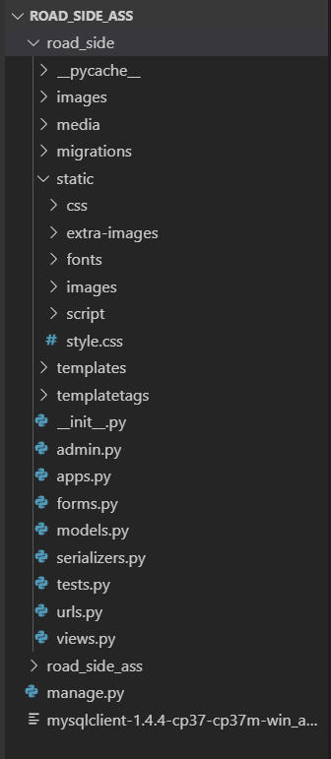

**2. Python Coding Style:-**

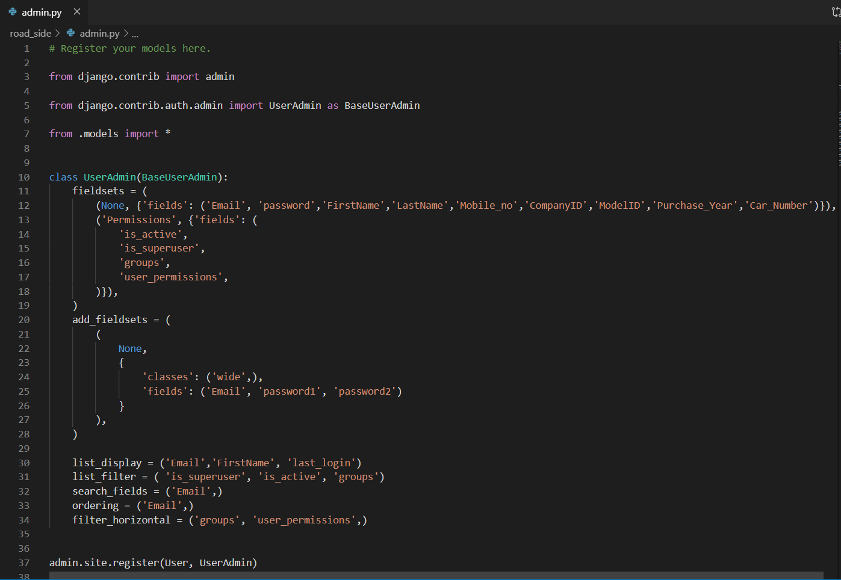

**3. Template Style:-**

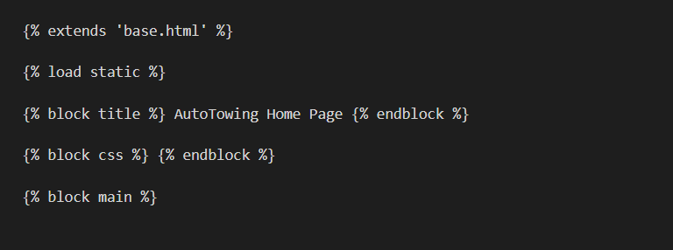

**4. View Style:-**

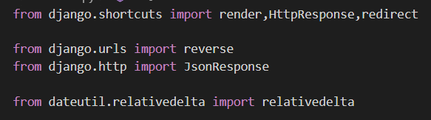

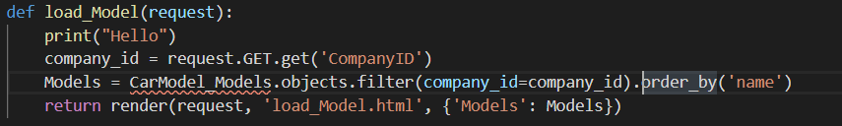

**5. Model Style:-**

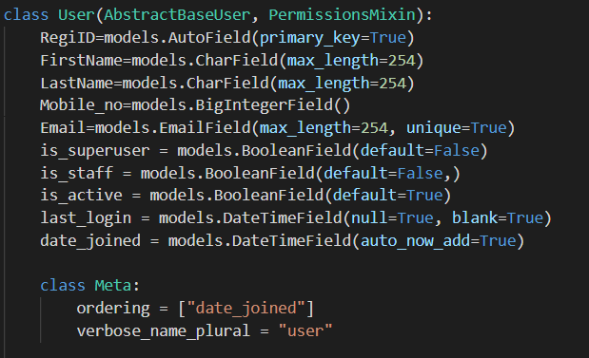

**6. Django Configuration:-**

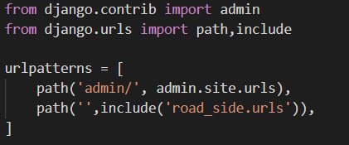

**Agile Documentation**

**5.1 Agile Project Charter:**

|  |  |
| --- | --- |
| 1. **SUMMARY** | |
| **Project Name** | **NS Motor Club** |
| **Executive Sponsor** | **L. D. College of Engineering** |
| **Project Manager or Lead or Member** | **Sumeet Tilokani, Nisarg Sheth, Sonu Prajapati** |
| **Project Start – End Dates** | **25/6/2019 – 10/10/2019** |
| **Project Purpose** | **The main objective of NS Motor Club is to provide emergency road side assistance services round the clock to ensure a pleasurable and uninterrupted journey virtually anywhere.** |
| **Budget /Resources** | **3 developers** |
| **Approved Date** | **01/07/2019** |

|  |
| --- |
| 1. **SCOPE** |
| **Purpose:** *The application is designed to enhance the user experience and ensure that users get immediate and hassle free service in the event of any vehicle breakdown.*  **Background:** *Our team shall make all possible efforts to locate and direct the nearest service provider to user’s location.*  **Inclusion/ Exclusion Criteria (mandatory):**  ***Inclusion***   * *In our website we are allowing user to upload photos, videos and description.* * *We show them suggested post for them.* * *We allow user to manage their profile.* * *We allow user to chat with each other.* * *We are allowing user to like and comment on post.*   ***Exclusion***   * *We do not allow user to share inappropriate post which is part of our terms and condition.* |
| 1. **BENEFITS** |
| * **People will get a platform where they can share their talent and get valuable feedbacks or help.** * **If they find some talent or skill of others valuable for them, they can connect with each other using chat feature.** * **People will get suggested post on bases of their like history.** * **People will be able to connect each other for item purchase or small event management or stuff.** |

|  |  |  |  |
| --- | --- | --- | --- |
| 1. **POTENTIAL ISSUES & RISKS** | | | |
| **Issue / Risk** | **Description** | **Probability**  **(H, M, L)** | **Impact**  **(H, M, L)** |
| Inappropriate post | Image processing is in our future enhancement, if someone posts inappropriate post we have to wait someone to report that post so admin can take actions. | L | H |
| Fake post | People can share fake post to misguide people. | H | L |
| Scam | If people are connecting for deal or something there is probability of scam. We can warn people to be aware of scams but we cannot control it. | L | H |

|  |
| --- |
| 1. **PROJECT BUDGET/ RESOURCES** |
| * Three members are involved in this project for the work of designing, developing, testing and data handling process. |

|  |  |  |
| --- | --- | --- |
| 1. **PROJECT TEAM** | | |
| **Role** | **Name** | **Business Area** |
| Internal Guide | Bhavesh Oza | Professor |
| Member | Sumeet Tilokani | Designer/Developer |
| Member | Nisarg Sheth | Project Testing/Data Handling |
| Member | Sonu Prajapati | Designer/Developer |

|  |  |  |
| --- | --- | --- |
| 1. **AUTHORIZATION** | | |
| Approved by Internal Guide: |  | Date: 01/07/2019 |
| Approved by Institute: |  | Date: 01/07/2019 |

**5.2 Agile Roadmap/Schedule**

**5.3 Agile Project Plan**

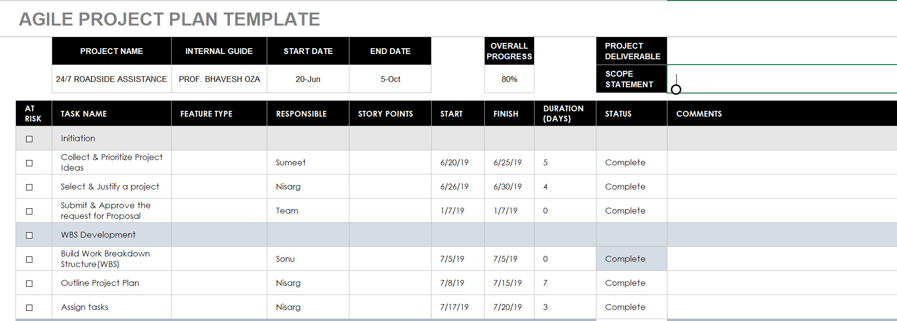

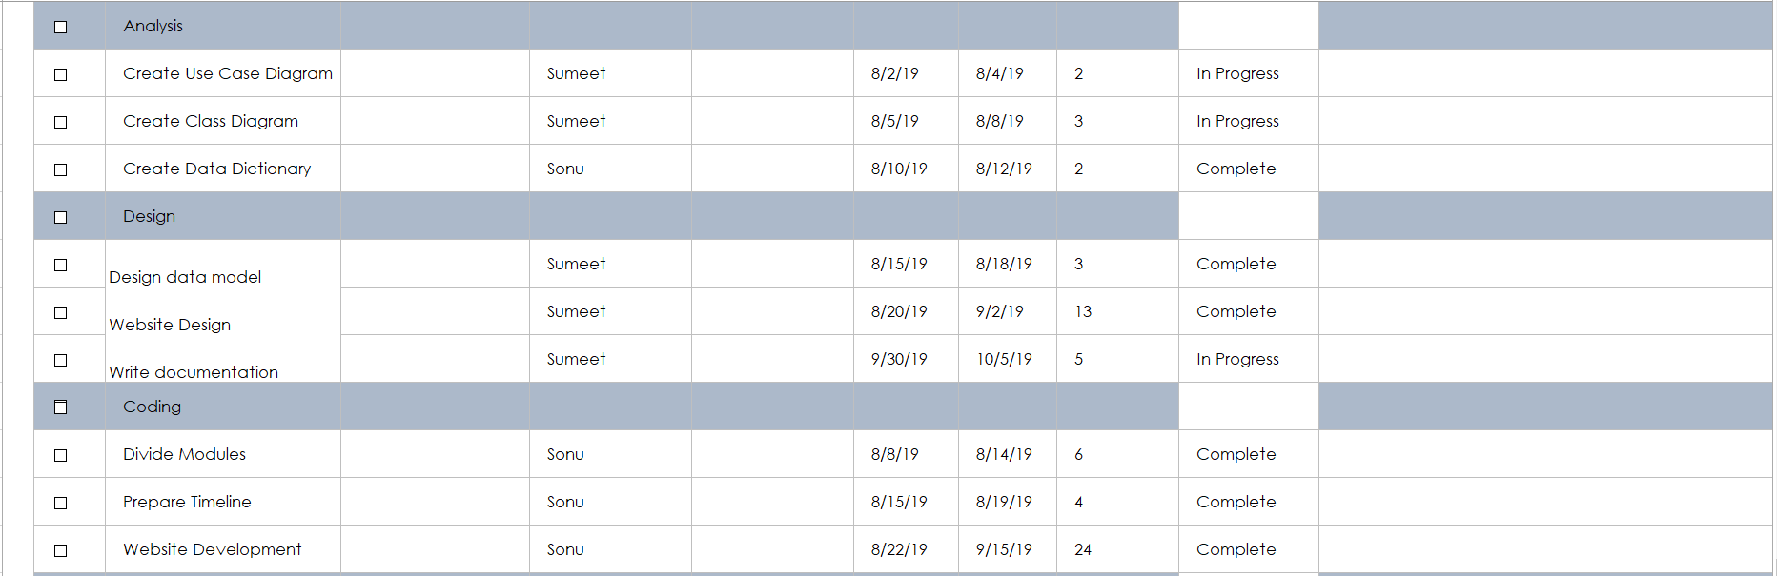

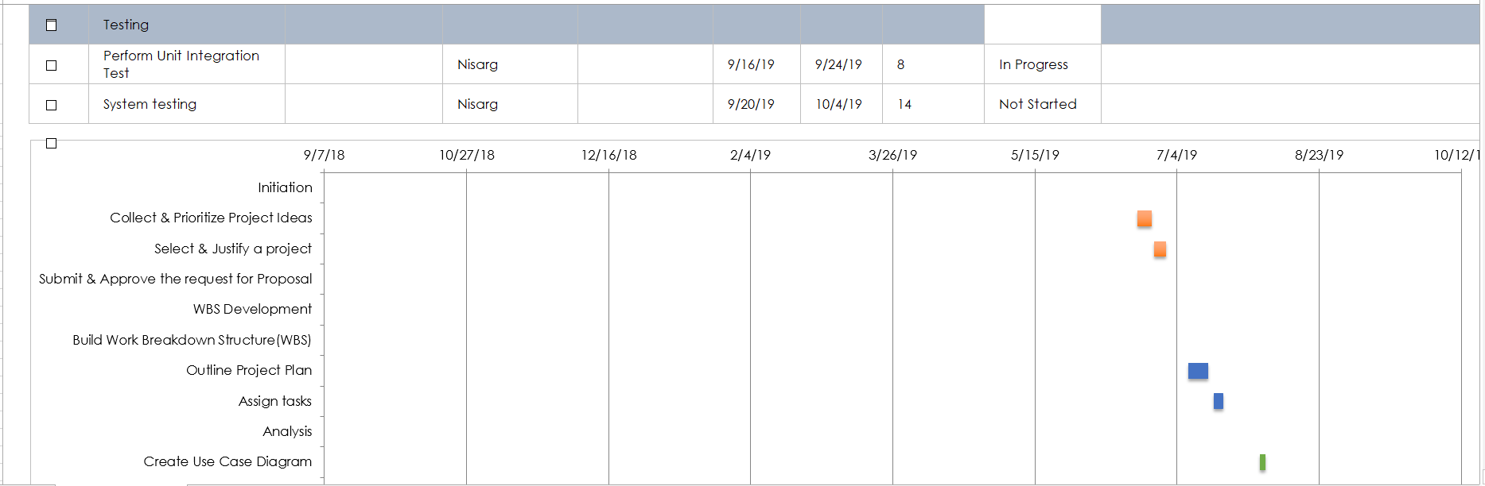

**5.4 Agile User Story**

**5.5 Agile Release Plan**

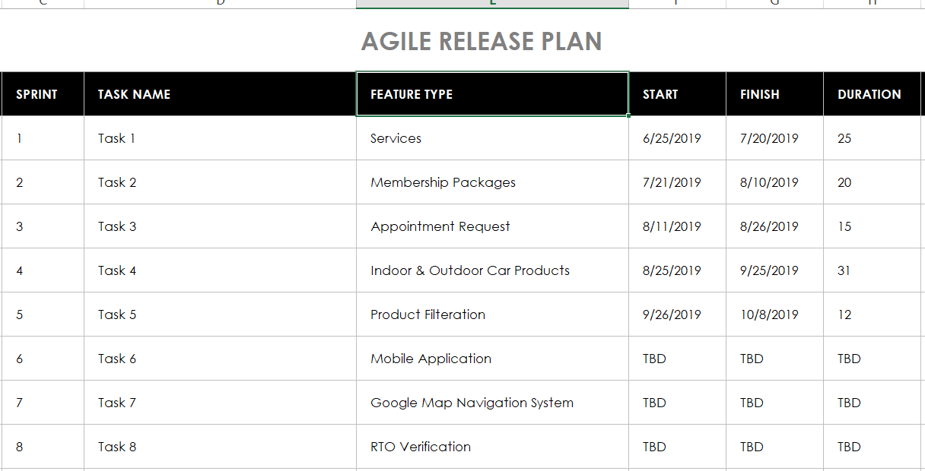

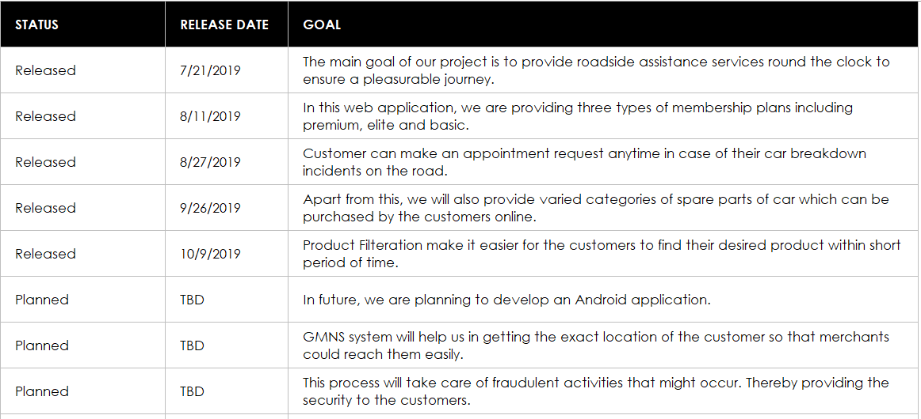

**5.6 Agile Sprint Backlog**

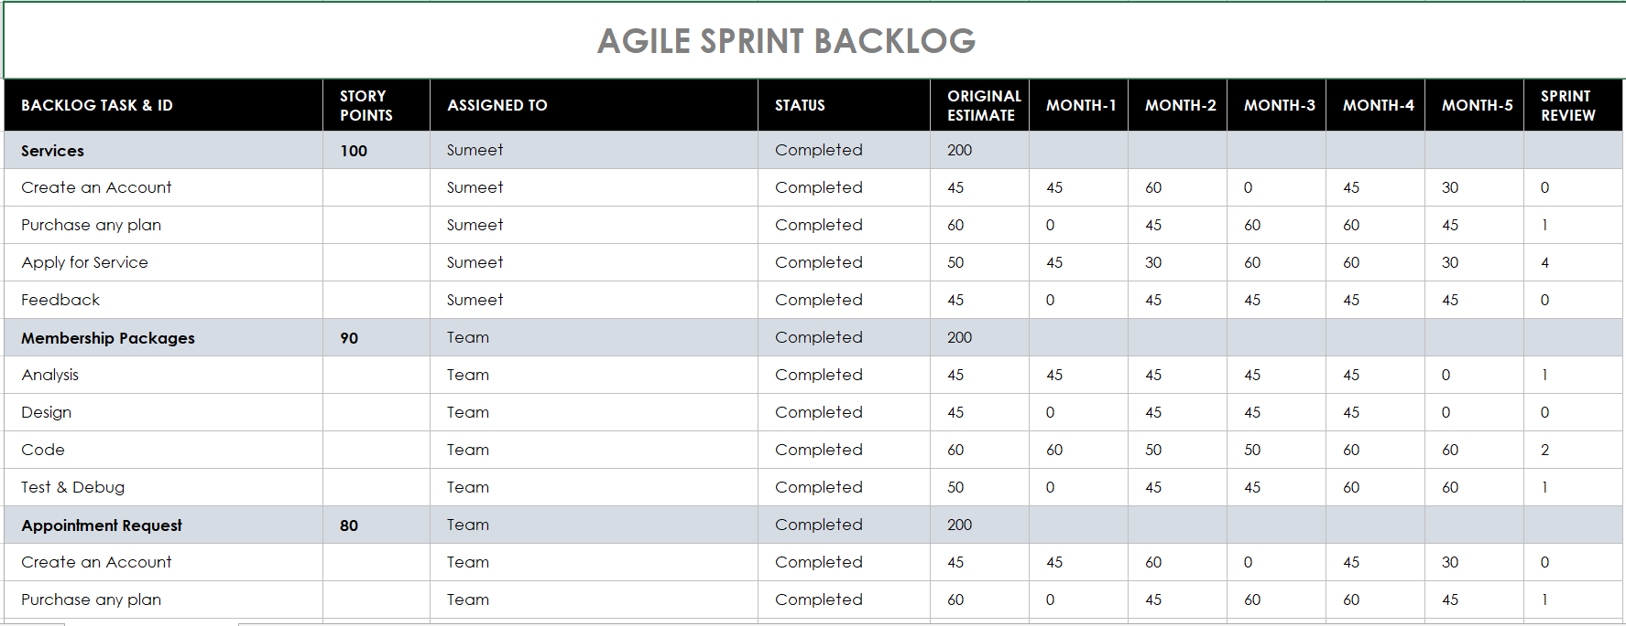

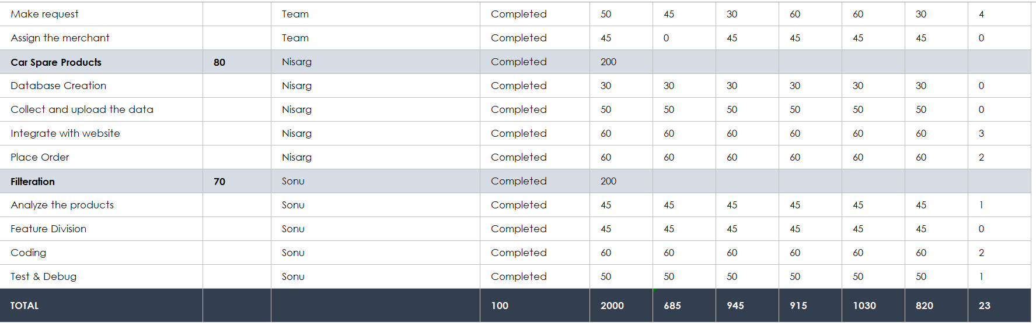

**5.7 Agile Test Plan**

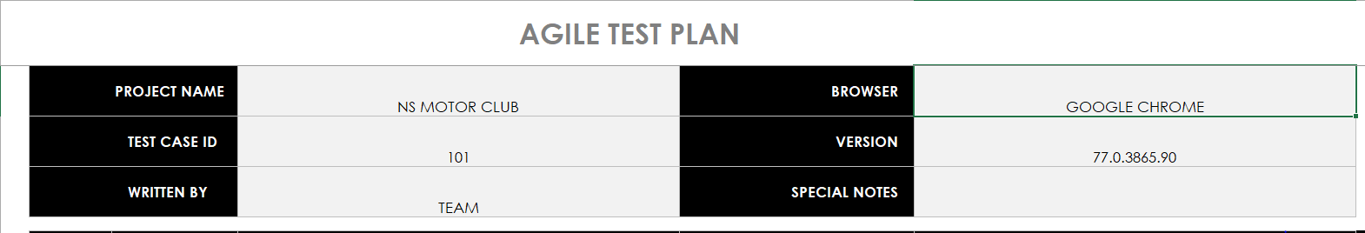

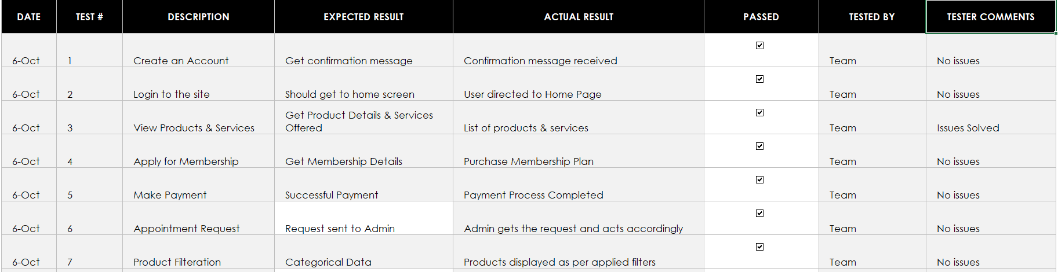

**5.8 Earned Value and Burned Chart**

**Proposed Enhancements**

NS Motor Club web application can be added with more enhanced features like user’s current location detection using Google Maps Navigation System, live weather reports and availability of emergency services such as ambulance, hotel, etc. based on the user’s location will ease. By adding more inputs for the services like Towing and Flat tyre providers, the precision and availability of the data for requested details can be improved.

The current system is designed and developed in Python using Django Framework which can also be done in several other technologies like Android and IOS. This will make more reach to large number of users. Also we are planning to develop an Android app of this system which will soon be available on the Google Play Store.

Apart from this, we will also be verifying the car details from the RTO Department, i.e. security. It will providing the chatbot facility where customers can resolve their queries or issues quickly. Also, we are planning to add product suggestions relating to their past orders or they mostly view.

**Conclusion**

* In conclusion, the problems faced by the drivers are not solely car breaking down. Car breakdown will cause frustration to the driver, the frustration will then cause the driver to make bad decisions and being scammed by the tow truck scammers.
* Another problem is getting help from workshops or mechanics. One who does not possess any workshop’s number can only rely on the help of a car passing by and risk being scammed.
* Based on all these related problems, it is vital to come out with a solution that can solve these problems.
* Revising back the background studies, the current way of how people obtain service from workshops might be satisfying such as the service provided by general automobile company, the existing system might be designed to be more helpful for those who faces car breakdown difficulties, however the development of this project aims to improve the way on how the public contact the car repair service providers and to provide convenience for both sides.
* The development of NS Motor Club also aims to overcome the flaws of some of the existing web applications in the market.
* The development of this application also fits the purpose of education studies and meets the requirement as stated in early stages and of course providing help to people who are in need.

**Bibliography**

**Follow the links**:-

1. <https://www.djangoproject.com/>
2. <https://realpython.com/django-setup/>
3. <https://www.stackoverflow.com/>
4. <https://code.visualstudio.com/docs/python/tutorial-django>
5. <https://www.tutorialspoint.com/django>
6. <https://www.smartsheet.com/>

**Books**:-

* Django for Beginners: Build websites with Python and Django – by William S. Vincent
* Django 2 by Example – by Antonio Mele
* Lightweight Django **-** by Elman and Mark Lavin
* Beginning Django: Web Application Development and Deployment with Python